Winter Fairytale Quilt
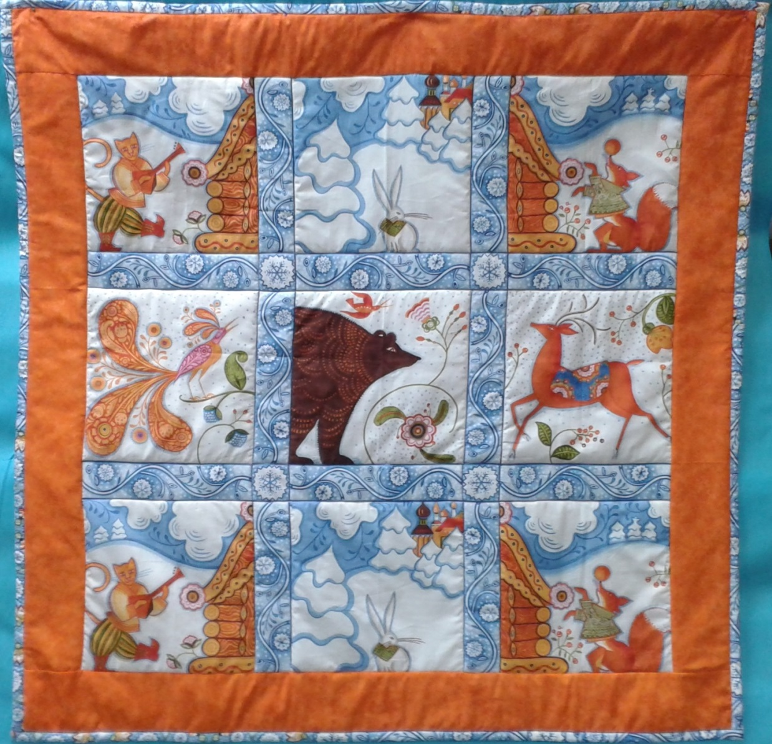
The kit package contains a printed cotton panel, a piece of wadding and instructions.
You will need to add either 1.5 metres of cotton fabric for the backing and border, or 40 cm of border fabric and 1.10m of backing fabric. We used Makower 'Spraytime' fabric 2800 N56. You will need 25 cm of plain white cotton fabric, cut into 2 inch strips, to line the binding. You will need cotton sewing thread, and a basic sewing kit.
The finished quilt is approximately one metre square.
You can make this quilt by hand, or use a sewing machine. If you are quilting with a machine, you will need a 'walking foot' to stitch the fabric, wadding and backing together smoothly, without puckering.

The 'Winter Fairytale' Quilt makes a perfect playmat for a winter baby (the colours suit either a boy or a girl), a cosy lap quilt for cooler evenings, or a fabulous festive throw to drape along the back of a sofa as Christmas approaches. The Scandinavian design is fresh and original, fitting effortlessly into any setting, be it a minimalist open plan flat or a homely cottage.
1. Cut the two border design strips from the selvedge edges of the fabric. Cut along the thin blue line at the edge of the printed design. Then cut off the blue border from three sides of the panel. Cut carefully and accurately along the thin blue line which defines the border pattern. You now have 5 strips of border pattern, 2inches wide, for binding your quilt. You also have one big square panel of nine designs, which will form the centre of your quilt. Set the binding strips aside.
2. Cut 4 strips for your border 'framing' the quilt. These need to be across the width of you fabric, 112cm/45 inches. Each strip needs to be 4 inches wide. Do not make your border wider than this: you will not have enough binding for a larger quilt. (If you choose to make your quilt bigger, you will need to add some extra fabric to your binding). Cut the side borders to fit the sides of the panel, and sew them on, using a quarter inch seam. Press the seam towards the border, do not open the seam to press it. Cut the remaining strips to fit across the top and bottom of the panel and the two side borders. Sew these on, and press towards the border.
3.Take your 1.10m of backing fabric, press it, and lay it flat, wrong side up, on a flat surface. Smooth it out beautifully. Lay your wadding on top of this, then lay the quilt top, right side up, on top. Make sure you place your quilt top so that the backing fabric and wadding extend further than the edges of the top for an inch or two on every side. Make sure that all the layers are smooth and flat. Tack the 'quilt sandwich' together, working from the centre outwards, putting lines of tacking about 5 inches apart, in both directions. You will end up with a grid of tacking stitches. Tack all around the perimeter of the quilt, about a quarter of an inch in from the edge.
4. Quilt by hand or machine. If using a machine, you will need to attach a walking foot. Contact your machine supplier if you do not have a walking foot: you need one which will fit your specific machine. Simply stitch along the blue lines dividing the panel motifs, or outline some of the details. If quilting by hand, space your stitches evenly, and do not pull them too tight. When you have finished, trim the excess wadding and backing to align with the edge of the quilt front, all around the perimeter of your quilt.
5. You do not have much spare fabric on the border strips, so be careful not to waste any. I cut the two multi coloured strips in half, and stitched them to sections of the blue and white strips, so I had bits of each design on each side of my quilt (see photograph). You could just sew all 5 strips together into a long 'ribbon', and cut off lengths as required. Do not have too many joins, or you will run out of fabric. I had one or two joins on each side, and had 4 inches of fabric left over. There is not much room for error here!
Cut 4 x 2 inch strips from the 25cm piece of white fabric. Use these to line the bindings. (the binding will have seams, but the linings should be long enough to not need joins). Lay one strip of binding to the front edge of one of the sides of your quilt, with right sides of the fabric together. Lay a strip of white fabric over the binding, matching the edges. Tack through the lining, binding and quilt, then stitch by hand or machine half an inch in from the edge. Turn the binding over the raw edge, turn under half an inch, and tack the binding so that it just covers the line of stitching. Slip stitch neatly in place. Repeat on the other side of the quilt, then sew the bindings to the top and bottom edges. Tuck in the raw ends of fabric on the corners, and sew neatly.
Remove all tackings, secure and cut any loose ends, then your quilt is finished.
If you have any questions, come and ask us at the shop, (preferably before you do any cutting!) or look online for tips about quilting and binding. The Patchwork and Quilting magazine has a page about basic techniques in every issue, and you may find this useful.
If this is your first quilt it could be the start of a big creative adventure! See our website or come into the shop for our programme of classes and workshops, and add to your repertoire of skills under the guidance of our expert tutors.
Spinning Weal
2015

